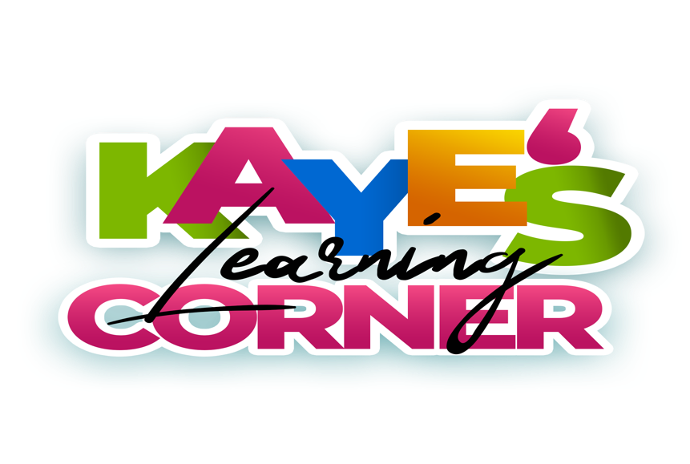

Year Round Service Contract

Kaye’s Learning Corner LLC is a learning program that believes every child has the right to a safe start, fair start, moral start, healthy start & a head start!
Kaye believes each child is capable of meeting academic excellence; it is our job to tap into the greatness within.

Kaye’s Care is the BEST care!

New Families are required to pay two weeks of tuition upfront plus a fifty dollar Enrollment Fee

*THIS IS NONREFUNDABLE *

Please submit your child’s immunization record upon time of enrollment.

- Monday at Kaye’s Learning Corner we open at 7:30 am and close at 6:00 pm
- Tuesday through Friday operation hours are 6:30 am - 6:00pm
Drop off cut off time is 9:00am … Every Family is given ONE late pass a month.

Doctor appointments , Family Emergencies should be communicated with Ms. Crystal so that we can ensure we are able to meet our families needs.

- Kaye’s Weekly Tuition Breakdown

- Infants are $200.00 Weekly
- Families of 1 tuition rate is $175.00
- Families of 2 tuition rate is $275.00
- Families of 3 tuition rate is $375.00

- If your payment is late on Monday Morning an additional $25.00 will be added & a 10.00 inconvenience fee every day after, until Wednesday. If not paid by Wednesday morning littles will not be allowed at school until tuition is paid in full.

- Summer session we swim on Thursdays we will dismiss at 3pm from the linwood YMCA.

- NO late care will be offered these days.

- Kaye’s parents MUST provide cleaning supplies the TOP of EVERY month, if cleaning supplies are not submitted by the 5th of each month $25.00 will be added to the next weeks tuition.

Kaye’s Daily Schedule:

6:30 a.m. - 8:30 a.m. Early Morning Arrival

8:30 a.m. -9:15a.m. Student arrival & breakfast

9:15 a.m. - 9:30 a.m. Preparation for Morning Instruction

9:30 a.m.- 10:30 a.m. Circle Time

10:30 a.m. - 11:00 a.m. Comprehensive Groups

11:00 am - 11:30 pm First Lunch / Brain Break

11:30 p.m.- 12:00p.m Second Lunch

12:30-2:30 p.m. Nap Time

2:30 p.m. - 3:00 p.m. Transition to Afternoon Instruction

3:00 p.m.-3:30 p.m. STEM, Music, Art, Swimming & Boxing!

3:30- 4:30 p.m. Dismissal

4:30 p.m.-6:00 p.m. Aftercare

Kaye’s Learning Corner observes ALL HOLIDAYS

no instruction virtual or in person will be given.

Please be advised that tuition is still due on the weeks we are on break.

If your child(ren) is sick and show any symptoms you will be asked to pick them up and they may not return until they are 24 hours free of fever and symptoms.

Parents MUST wear a mask when coming to sign children in

Immunization records need to be submitted with completed application.
Kaye’s is a learning program where we believe our children reach their best potential with family support, so we do ask that parents are compliant and engaged with their kiddos learning

Each parent that is receiving in person care is asked to supply the following monthly

Clorox Wipes
Hand sanitizer
Lysol
Hand soap

If your little are in diapers / pull ups you are expected to provide enough ti stay at the center . Along with a extra change of clothes

Please be prepared to check Brightwheel DAILY it is our main source of communication.

Tuition for the Learning Corner can be paid in these forms

Cash, Check, Square, Cashapp $KayesLearningCorner

Additionally, please understand that parent compliance is a key factor in the everyday success of Kaye’s Learning Corner parent’s failure to comply. Lack of respect of staff, lack of supplying contributions , late tuition on a continued basis can result in your child being dismissed from Kaye’s Learning Corner.

____________________________________
Crystal Turner, CEO

____________________________________

Nina Farrell, COO

Name of Student(s):

__________________________________
Signature

Emergency Contact Information:

Name: ___________________________

Phone#: ________________________

Signed Contracts can be scanned and emailed to kayeslearningcorner@gmail.com

Kaye’s Learning receives donations from many businesses. Many times, they request to take photos for their documentation of services provided. By checking Yes below, you give Kaye’s Learning permission to use photos, images, video recordings (where applicable) of your child(ren)

_____Yes, I consent to Kaye’s Learning Corner and its affiliates to use images/videos recordings of my child(ren).

____No, I do not consent to Kaye’s Learning Corner and its affiliates to use images/video recordings of my child(ren).

For Internal Use Only
******************************************************************************

Deposit Amount: $___________________

Parent Name:
Contact Phone Number(s)

